INTRODUCTION:
Vibration control is a set of technical means aimed to mitigate seismic impacts in building and non-building structures.
All seismic vibration control devices may be classified as passive and active where:
1. Passive control device (TMD, Base Isolator) imparts forces that are developed directly as a result of motion of structure (i.e., no actuator involved).
2. Active control devices incorporate real-time recoding instrumentation on the ground integrated with earthquake input processing equipment and actuators within the structure.
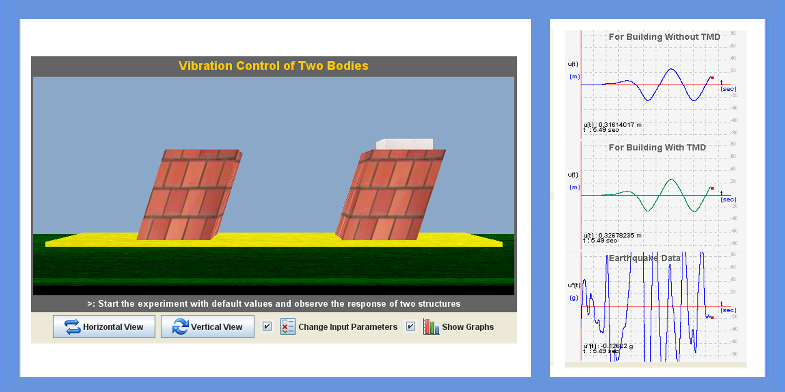

THEORY:

Dampers or isolators stabilize against violent motion caused by harmonic motion . It balances the vibration of a system with comparatively lightweight component so that the worst-case vibrations are less intense.
Acceleration is decreased because the base isolation or damping system lengthens a building's period of vibration, the time it takes for a building to rock back and forth and then back again. And in general, structures with longer periods of vibration tend to reduce acceleration, while those with shorter periods tend to increase or amplify acceleration. The building's displacement in the direction opposite the ground motion is actually due to inertia. The inertia forces acting on a building are the most important of all those generated during an earthquake.
When building begins to oscillate it excites the Tuned Mass Damper (TMD) into motion. The TMD inertia forces produced by this motion are approximately anti-phase to the dynamic forces driving the building .Building motion thus greatly reduced with the dynamic forces primarily driving the TMD instead of building. The energy of this motion is dissipated by the internal damping mechanism associated with TMD.
When the ground shakes, the rollers freely roll, but the building above does not move. Thus, no force is transferred to the building due to the shaking of the ground; simply, the building does not experience the earthquake. You may notice that displacement of building reduces by using base isolators.

A tuned liquid damper (TLD) system represents an efficient and simple technique to increase the damping of a structure. It involves the attachment of one or multiple liquid – filled tanks to the structures. The TLD system relies on the sloshing wave developing at the free surface of the fluid to dissipate a portion of the dynamic energy. When building starts vibrating TLD also starts vibrating, due to sloshing effect it can control the vibration of the structure.

OBJECTIVE:

Objective of vibration control experiment is to understand how dampers or isolators can control vibration of Structures

MANUAL:
Start the experiment with the default values of mass and stiffness of the structure, and default values of mass and stiffness of Tuned mass damper(TMD). Observe how structure is vibrating due to external loads.
Observation 1: Experiment starts with default mass and stiffness of structure. User can change the values of mass and stiffness of TMD. Observe how structure is vibrating due to external loads with TMD and without TMD.
Observation 2: In this stage, user can change mass and stiffness of structure as well as mass and stiffness of TMD. User can also change the damping value of TMD and earthquake data. Observe how structure is vibrating due to external loads with TMD and without TMD.

PART - 2
ANIMATION STEPS
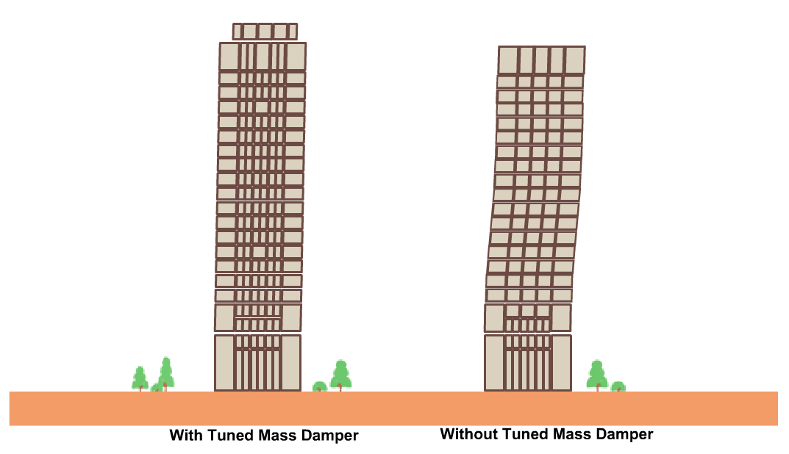
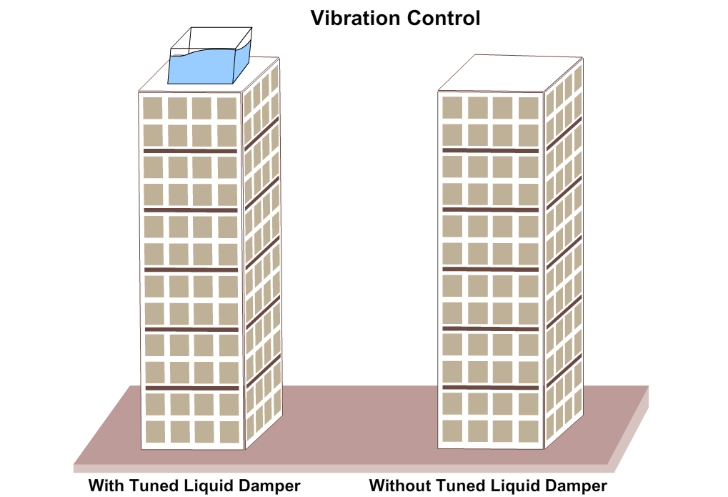

PART – 3
VIRTUAL LAB FRAME
